Brief on Handloom Sector

“Our problem being to form the future, we can only form it on the materials of the past; we must use our heredity, instead of denying it.” - T.S. Eliot

Evolution of Handloom Sector in India
India has a rich tradition of handloom weaving since time immemorial with the earliest evidences going back to the Indus Valley civilisation.
Various written treatise pertaining to the Rigveda, Ramayana, Mahabharata, Thalia (by Greek historian Herodotus) and Kautilya have mentioned not only spinning and weaving but also the high quality of silk and cotton.
Export of handloom products, as early as the ﬁfteenth century was reported, followed by Vasco da Gama’s visit to India thereby opening of trade routes for Europe. Further, Jean-Baptiste Tavernier’s memoirs from the seventeenth century mention Burhanpur in Madhya Pradesh as hub for international trade with exports to Egypt, Poland, Russia and the Gulf region. Further, it is said that by the end of the seventeenth century, 83% of The East

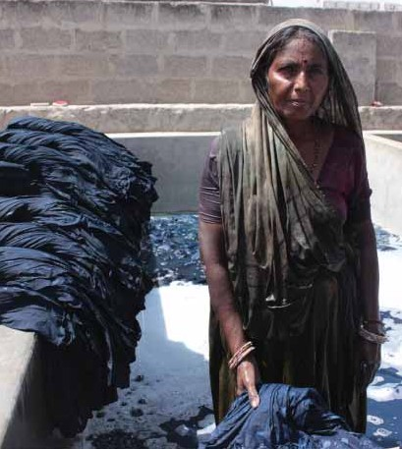
India’s Company trade accounted for clothing exports. Summing up this robust trade, Daniel Defoe stated that “everything that used to be made of wool or silk, relating to either the dress of women or the furniture of houses, was supplied by the India trade”.
With the advent of the Industrial Revolution, the British began executing a protectionist policy in order to restrict import of handwoven cloth from India (to Britain) while dumping their machine made clothes, in India, from Lancashire. Towards the end of the nineteenth century, the cotton textile sector suﬀered from a range of challenges from economic recessions to natural calamities. In fact, for the period ranging end of the nineteenth century and the ﬁrst three decades of the twentieth century, there was an ongoing tussle between dumping of British mill products versus Indian hand woven textiles with the rising call of Swadeshi goods.
Despite such adversity, Indian artisans have stood the test of time and have kept this great craft alive. Over the centuries, handlooms have come to be associated with excellence in India’s artistry in fabrics. Fabrics and designs were inﬂuenced by geographic, religious and social customs of a region. Diﬀerent parts of India have produced distinct styles – muslin of Chanderi, Varanasi brocades, Rajasthan and Orissa have given tie and die products, Patola sarees from Patan, himroos of Hyderabad, phulkari and Khes from Punjab, Daccai and Jamdani from Bengal, traditional designs from Assam and Manipur like the Phenek and Tongam. Indian handloom designs and weaves have been famous world over and it is important to ensure sustenance of our cultural heritage.

Women’s empowerment through ﬁnancial independence
Indian handloom sector is ancient and has served the economy well in terms of employment. The sector is very important from the point of view of its size and employment potential. The relevance of the handloom sector in the agrarian economy is massive because of its linkages with crucial and sensitive sectors like agriculture. It uses agricultural products as raw materials and, therefore, provides an ever-ready market for agricultural produce. Therefore, in an economy where majority of people still rely on agrarian sector for their livelihood, the signiﬁcance of handloom is well understood.
Secondly, it is a sector that directly addresses women’s empowerment. As per the present census, the sector engages over 23 lakhs female weavers and allied workers. The handloom sector is largely household-based, carried out with labour contributed by the entire family. Therefore, the engagement of a large number of women (over 70% of all weavers and allied workers are female) in any capacity in this sector has ensured direct remunerations for them, thus empowering them through ﬁnancial independence and improved self-worth both within and outside of their homes.

Key milestones for the sector
August 15, 1947 marked a turning point for the handloom weavers of India. Mahatma Gandhi’s use of Charkha, the spinning wheel, as a symbol of national regeneration and the subsequent focus on the handloom weavers during the freedom movement was largely responsible for the breakthrough.
The dawn of Independence provided an opportunity to accord priority treatment to the handloom sector. At the time of Independence, there were about three million handlooms in India, largely of poor quality because of inferior raw material and ill-organised marketing infrastructure. The situation worsened in 1952 due to a slump in the textile market. The All- India Handloom Board was reconstituted seven years after its dissolution in 1945, to advise the Government and propose schemes for the development and survival of handlooms.

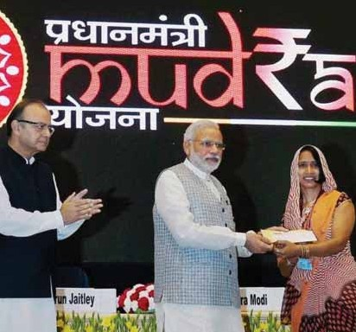

With a view to raising funds for the sector and organising weavers’ cooperatives, Parliament had passed the Khadi and Other Handloom Industries Development Act in 1953. To facilitate marketing of fabrics made in the handloom cooperatives, a national level apex body called the All India Handloom Fabrics Marketing Cooperative Society was set up in 1955. The Weavers Service Centre and the Indian Institute of Handloom Technology were set up to provide infrastructure back up in the vital areas of applied research, service and training.
The Handloom and Handicrafts Export Corporation of India Ltd (HHEC) was set up in 1958 to promote export of handlooms. In 1976, the Government appointed a high powered study team and on its recommendations the Oﬃce of Development Commissioner for Handlooms was created at the Centre to ensure a scientiﬁc growth of the handloom sector. Since then the Oﬃce of the Development Commissioner for Handlooms has been implementing various developmental and welfare schemes for the beneﬁt of the handloom weavers. To ensure a steady supply of raw materials such as yarn, dyes and chemicals to the handloom sector, the National Handloom Development Corporation (NHDC) was set up in 1983.

Major interventions by Government of India
Ministry of Textiles through the Oﬃce of the Development Commissioner for Handlooms is working for the sustainable development of the handloom sector by implementing

various developmental, promotional, and welfare schemes. The principal objectives of these schemes is to promote production and marketing of high quality and high value handloom products and thereby increase the earnings of weavers and other workers associated with this sector. Skill up-gradation, infusion of new and contemporary designs, product diversiﬁcation, technology upgrades, improved access to subsidised raw materials, access to low interest credit, common infrastructure development, brand building, marketing assistance including promotion of e-Commerce platforms and linking handloom with high-end fashion, are but some of the major interventions initiated by the present Government. The following sections provides a more in-depth look at some of the ﬂagship initiatives that have created signiﬁcant impact on the lives of those associated with the production of handloom cloth.
    - Block level cluster
The block level cluster scheme aims at integrated and holistic development of identiﬁed handloom pockets through various interventions like skill up-gradation, Hathkharga Samvardhan Sahayata (HSS), construction of individual work sheds, design and product development,

creation of Common Facility Centres, etc. with GoI assistance to the tune of Rs.2 crores per cluster. While funding for most components is 100%, there is additional funding to the tune of Rs.50 lakhs available for setting up one Dye House in a district to ensure availability of quality dyed yarn for weavers. The cluster projects are taken up upon recommendations from the State Government.
    - Skill up-gradation
Skill up-gradation training and exposure is given to weavers and allied workers for learning new weaving techniques, adaption of new technology, development of new designs and colours, learning about new types of eco- friendly dyes and dyeing practices, exposure to basic accounting and management practices, familiarisation with e-commerce, etc.
    - Hatkharga Samvardhan Sahayata (looms and accessories)
HSS aims to improve the fabric quality and improve productivity through adoption of upgraded looms/jacquard/dobby, etc. Under this scheme, 90% of the cost of looms and accessories is borne by Government of India but the implementation is done with the full involvement of respective State Governments.

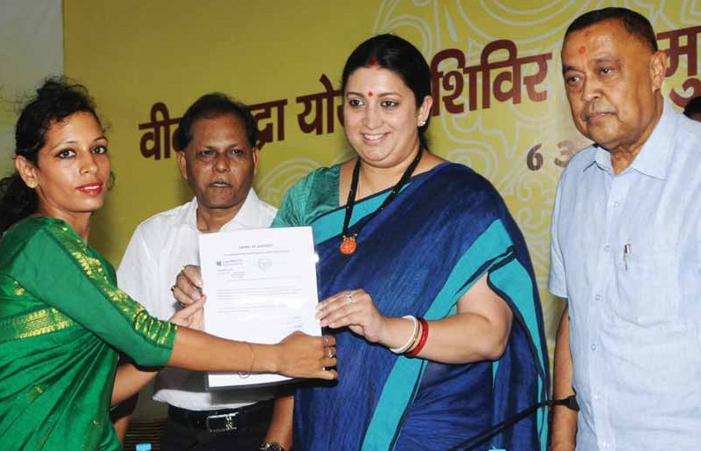

    - Work shed
The construction of individual work sheds envisages providing a working space for the entire weaver family close to their home. The unit cost for these sheds are Rs.1.2 lakhs and marginalised households and female weavers are eligible for 100% ﬁnancial assistance.
    - Engagement of designers
There is a provision for engaging professional designers in the block level clusters and beyond to design new innovative designs and products. The scheme not only pays for their fees, but further outlay is available for providing additional remuneration to designers for establishing marketing linkages.
    - Yarn supply
Under this scheme, yarn is supplied at mill gate price to weavers to compensate them for the high cost of transportation from mill gate to their workplace. In addition, 10% price subsidy is provided on cotton, domestic silk, woollen and linen yarn in hank form so that handloom weavers can compete with power- looms in pricing. To facilitate regular and timely supply of yarn, yarn depots have been opened in handloom concentrated areas. To reduce delivery period and also facilitate delivery of small orders, warehouses have been opened in all States having signiﬁcant handloom presence.
    - MUDRA loan
Under this scheme, working capital and term loans at 6% interest rate is being provided through banks. To leverage these loans, margin money up to Rs.10,000 is also provided. The Ministry also bears the credit guarantee fee to be paid to the banks to encouraging lending. The Online Handloom Weavers MUDRA portal has been developed for Direct Beneﬁt Transfer of margin money to weavers’ accounts and interest subvention and credit guarantee fees to banks.
    - Learning opportunities
To empower weavers and to enable the youth from weaver families towards career progression, MoUs have been signed between Ministry of Textiles and National Institute of Open Schooling (NIOS) and Indira Gandhi National Open University (IGNOU). Under this agreement, both NIOS and IGNOU have

designed distant education courses relevant for the handloom sector. The ministry provides 75% subsidy on the course fees for SC, ST, BPL and female weavers for handloom weaver families.
    - Bunkar Mitra helpline
“’Bunkar Mitra” helpline for handloom weavers has been set up with a toll free number of 1800
208 9988 to provide single point of contact to handloom weavers across the country for addressing their professional queries. The service is available in seven languages viz. Hindi, English, Tamil, Telegu, Kannada, Bengali, and Assamese. The services are available all seven days of the week.
    - Welfare measures
Under welfare measures, handloom weavers are covered under Pradhan Mantri Jeevan Jyoti Bima Yojana (PMJJBY), Pradhan Mantri Suraksha Bima Yojana (PMSBY), and Mahatma Gandhi Bunker Bima Yojana (MGBBY) (for those in the age group of 51 – 59 years). Under these schemes, weavers are required to pay only Rs.80 to enrol in these schemes while the rest of the premium is borne by Government of India.
    - Certiﬁcation
The Handloom mark was launched in the year 2006 to provide a distinct identity to handloom products. The India Handloom Brand (IHB) was launched in 2015 for branding high quality handloom products. IHB aims to provide a bridge between the weaver and the consumer, giving the former higher earnings and the later, an assurance of quality. All the products under the IHB are benchmarked for quality of the raw materials, the processing besides providing the origin from the handwoven sector. Various prominent brands like BIBA, Peter England and ONAYA have already launched exclusive range of handloom garments with IHB.
    - Marketing assistance
Expos and District level events are organised regularly to provide a marketing platform to the handloom weavers. Weavers are also facilitated to participate in various crafts melas held across the country. Marketing Incentive has also been provided to Handloom agencies. As a new initiative, 23 e-commerce companies have been engaged to promote e-marketing of handloom products.

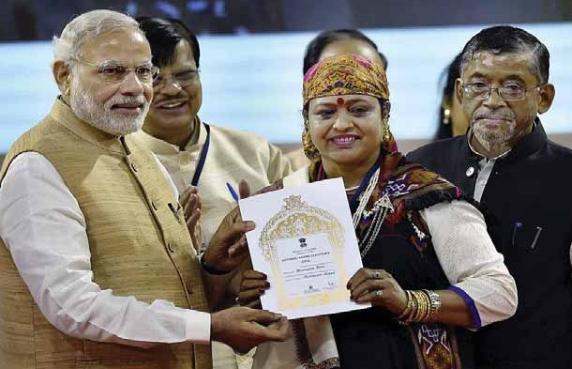

    - Handloom awards
Ministry of Textiles has been annually conferring various awards like Sant Kabir Award, National Award and National Merit Certiﬁcates, towards excellence in weaving, design development, and marketing eﬀorts.
In addition to the above, State Governments also have their own schemes where they have earmarked signiﬁcant outlays from their State budget towards betterment of weaver households in their State. These are initiatives over and beyond the centrally sponsored schemes which they partner in beneﬁciary identiﬁcation and implementation. Some of the States with prominent schemes of their own include West Bengal, Tamil Nadu, Telangana, Andhra Pradesh and Chhattisgarh.

